WOMEN’S HEALTH COLLEGE, NZNO
EDUCATION AWARD APPLICATION FOR
QUALIFIED NURSES & MIDWIVES
Applications are assessed four times annually at Women’s Health College (WHC) Committee face-to-face meetings. These meeting dates vary slightly each year.
If you have not received a reply to your application within
4-6 weeks, please contact the WHC Administrator.
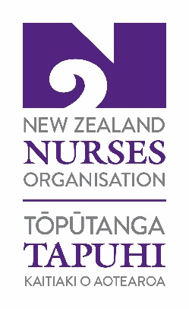
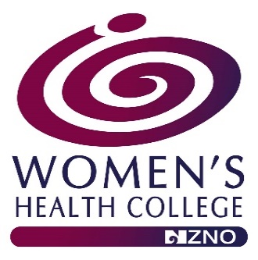

Name of Applicant
Address
Mobile
Email Address
NZNO Membership Number
(You must be a current financial member of NZNO).
Are you a member of the WHC (NZNO)?  (You must be a current member of the WHC (NZNO) to be eligible). | Yes ☐ No ☐
How much money are you requesting? (Maximum $450).
Please tick if you are a | Nurse Practitioner ☐  Registered Nurse ☐  Registered Midwife or ☐  Enrolled Nurse ☐
If you work, please state your position and the organisation you work for
Please provide details of the conference/ study you seek funding for, including:
- conference or course title,
- provider or organiser,
- costs involved
- dates and
- length of conference or course

Please include proof of enrolment/ attendance and a copy of the programme.
How will you use this conference/ to benefit nursing, midwifery, or healthcare in New Zealand?

Please note:
- In the event that your course, conference or study is cancelled, or you are cannot attend any money received from the WHC (NZNO) is to be returned with an explanation for the non-attendance.
Please outline all assistance (if any) you are receiving from your employer including:
- paid study leave,
- registration fees and
- travel costs etc.
In the event that the WHC committee approve your application, please supply your bank account details
Name of account holder
Bank account number

- Upon completion of your course, conference, study, you may wish to provide a paragraph about your experience for the WHC, NZNO newsletter.
This application must be complete, legible and
have the required information attached.
DECLARATION
I declare the contents of this application to be a true and correct record.
Signature:
Date:

Please email application to the WHC Administrator, sally.chapman@nzno.org.nz A reply to your application will be sent within 4-6 weeks. If you do not receive one, please contact our Administrator.

The decision of the Women’s Health College (NZNO) National Committee will be final.

NZNO use only
Date application received by NZNO
Outcome/ approval by Selection Panel
Date
Nominee notification date
Amount awarded
NZNO Finance - date paid
NZNO Admin - date entered into Mems database

